|  |  |  |  |  |  |  |
| --- | --- | --- | --- | --- | --- | --- |
| Electricity consumed by.. | Electricity consumed by.. | Total Electricity co.. | Line graph on comparison .. | 2019  Regionwise E.. | 2020  Regionwise E.. | Monthw ise Elec.. |

Usage

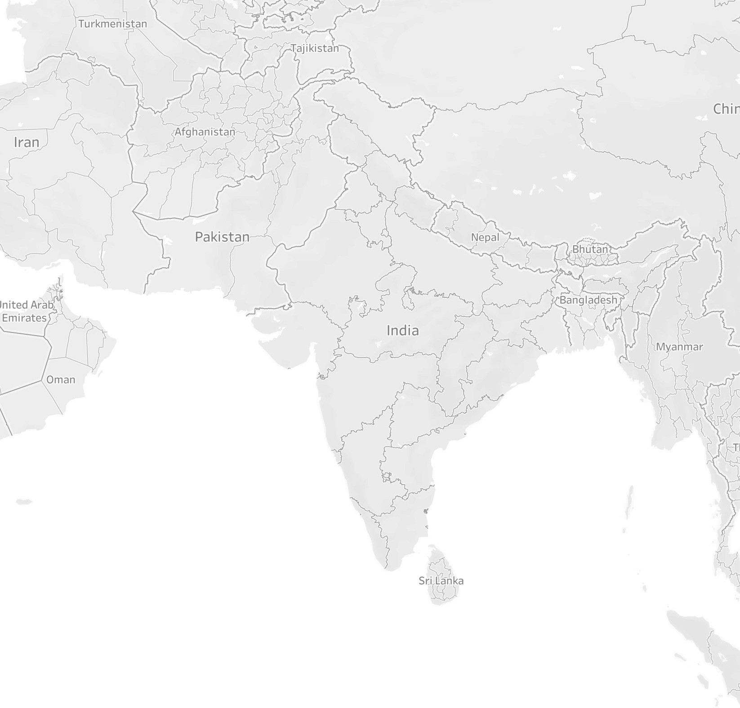

J&K 15,915

Punjab

49,636 Uttarakhand

12,899

Rajasthan 78,139

UP 112,690

Sikkim 466

Arunachal Pradesh 754

Nagaland 777

Gujarat 115,357

MP 74,975

West Bengal 49,869

Mizoram 614

Chhattisgarh 30,180

Maharashtra 154,917

Goa 4,007

Andhra Pradesh 63,097

Tamil Nadu 106,720

© 2023 Mapbox © OpenStreetMap

466 154,917

|  |  |  |  |  |  |  |
| --- | --- | --- | --- | --- | --- | --- |
| Electricity consumed by.. | Electricity consumed by.. | Total Electricity co.. | Line graph on comparison .. | 2019  Regionwise E.. | 2020  Regionwise E.. | Monthw ise Elec.. |

Usage



J&K 6,350

Punjab

21,361 Uttarakhand

5,288

Rajasthan 31,738

UP 45,270

Sikkim 182

Arunachal Pradesh 307

Nagaland 311

Gujarat 47,132

MP 29,792

West Bengal 19,902

Mizoram 244

Chhattisgarh 12,010

Maharashtra 62,163

Goa 1,573

Andhra Pradesh 25,507

Tamil Nadu 44,551

© 2023 Mapbox © OpenStreetMap

182 62,163

|  |  |  |  |  |  |  |
| --- | --- | --- | --- | --- | --- | --- |
| Electricity consumed by.. | Electricity consumed by.. | Total Electricity co.. | Line graph on comparison .. | 2019  Regionwise E.. | 2020  Regionwise E.. | Monthw ise Elec.. |

Year of 0K

Count of Consumption (1)

Dates

1K

2K

3K

4K

5K

6K

7K

8K

9K

10K

11K

12K

2020

**4,752**

2019

**11,847**

0K

1K

2K

3K

4K

5K

6K

7K

8K

9K

10K

11K

12K

Count of Consumption (1)

|  |  |  |  |
| --- | --- | --- | --- |
| Line graph on comparison .. | 2019  Regionwise E.. | 2020  Regionwise E.. | Monthwise Electricity c.. |

120K

Electricity Electricity Total consume.. consumed by.. Electricity co..

2019

2020

110K

100K

90K

80K

70K

60K

Usage

50K

40K

30K

20K

10K

0K

January February March April May June July August

September October November December January February March April

May June July August

September October November December

|  |  |  |  |  |  |  |
| --- | --- | --- | --- | --- | --- | --- |
| Electricity consume.. | Total Electricity co.. | Line graph on comparison .. | 2019  Regionwise E.. | 2020  Regionwise E.. | Monthwise Electricity co.. | Text table Analysis of .. |

117,915

ER

15,520

NER

Regions ER NER NR SR WR

Usage

1,216,205

385,281

WR

358,695

NR

338,795

SR

|  |  |  |  |
| --- | --- | --- | --- |
| 2020  Regionwise E.. | Monthwise Electricity co.. | Text table Analysis of El.. | Top 10 Electricity c.. |

Usage

Total Line graph on 2019 Electricit.. comparison .. Regionwise E..

ER

SR

WR

NR

6,191 155,089

|  |  |  |  |
| --- | --- | --- | --- |
| Monthwise Electricity co.. | Text table Analysis of El.. | Top 10 Electricity co.. | Bottom 10 Electricity c.. |

180K

Year of Dates

2019

Line graph on compa..

2019

2020

Regionwise E.. Regionwise E..

2020

160K

140K

120K

100K

Usage

80K

60K

40K

20K

0K

January

February

March

April

May

June

July

August

Septemb.. October November December

|  |  |  |  |
| --- | --- | --- | --- |
| Text table Analysis of El.. | Top 10 Electricity co.. | Bottom 10 Electricity co.. | Electricity consumed b.. |

States 2019 2020

2019 Regio nwise Ele..

2020

Monthwise

Regionwise E.. Electricity co..

Usage

Andhra Pradesh Arunachal Pradesh Assam

Bihar Chandigarh Chhattisgarh Delhi

DNH

Goa Gujarat Haryana HP

J&K Jharkhand Karnataka Kerala Maharashtra Manipur Meghalaya Mizoram

MP

Nagaland Odisha Pondy Punjab Rajasthan Sikkim Tamil Nadu Telangana Tripura

UP

Uttarakhand West Bengal

63,097

754

8,979

30,008

1,472

30,180

29,458

5,845

4,007

115,357

48,995

9,491

15,915

8,606

73,077

25,798

154,917

895

2,018

614

74,975

777

28,967

2,653

49,636

78,139

466

106,720

67,450

1,483

112,690

12,899

49,869

25,507

307

3,576

11,821

611

12,010

12,482

2,419

1,573

47,132

20,587

3,873

6,350

3,387

29,589

10,515

62,163

360

821

244

29,792

311

11,507

1,106

21,361

31,738

182

44,551

26,616

573

45,270

5,288

19,902

182

50,000

100,000

154,917

|  |  |  |  |
| --- | --- | --- | --- |
| Top 10 Electricity co.. | Bottom 10 Electricity co.. | Electricity consumed by.. | A plot on con sumption.. |

220K

200K

180K

160K

States

States

Gujarat Haryana Karnataka Maharashtra MP

Punjab Rajasthan Tamil Nadu Telangana UP

140K

120K

Usage

100K

80K

60K

40K

20K

0K

2020 Regio Monthwise Text table nwise Ele.. Electricity co.. Analysis of El..

Gujarat

Haryana Karnataka Maharas.. MP

Punjab

Rajasthan

Tamil Nadu

Telangana UP

|  |  |  |  |  |  |  |
| --- | --- | --- | --- | --- | --- | --- |
| Monthwise Electricit.. | Text table Analysis of El.. | Top 10 Electricity co.. | Bottom 10 Electricity co.. | Electricity consumed by.. | A plot on consumption.. | Electricity co nsumption.. |

States



1,088

2,839

858

3,759

1,061

2,083

1,255

649

2,055

8,265

Arunachal Pradesh Chandigarh

DNH

Manipur Meghalaya Mizoram Nagaland Pondy Sikkim Tripura

|  |  |  |  |
| --- | --- | --- | --- |
| Electricity consumed by.. | A plot on consumption.. | Electricity consumption.. | Tree map on Yearwise c.. |

180K

Text table Top 10 Bottom 10 Analysis .. Electricity co.. Electricity co..



160K



140K

120K

100K

Usage

80K

60K

40K

20K

0K

January February March April May June July August Septemb.. October November December

|  |  |  |  |
| --- | --- | --- | --- |
| A plot on consumption.. | Electricity consumption.. | Tree map on Yearwise con.. | A box and whisker plo.. |

340K

Top 10 Bottom 10 Electricity Electricit.. Electricity co.. consumed by..

320K

300K

280K

260K

240K

220K

200K

180K

Usage

160K

140K

120K

100K

80K

60K

40K

20K

0K

0 1 2 3 4 5

Quarter of Months

|  |  |  |
| --- | --- | --- |
| Electricity consumption.. | Tree map on Yearwise con.. | A box and whisker plot .. |

80K

Top 10 Bottom 10 Electricity A plot on Electric.. Electricity co.. consumed by.. consumption..

70K

60K

50K

Usage

40K

30K

20K

10K

0K

January February March April May June July August September October November December

Month of Dates [2020]

Top 10 Bottom 10 Electricity A plot on Electricity Tree map on A box and Electric.. Electricity co.. consumed by.. consumption.. consumption.. Yearwise con.. whisker plot ..

Usage

2019

1,216,205

2020

493,523

493,523 1,216,205

|  |  |  |  |  |  |  |
| --- | --- | --- | --- | --- | --- | --- |
| Top 10 Electric.. | Bottom 10 Electricity co.. | Electricity consumed by.. | A plot on consumption.. | Electricity consumption.. | Tree map on Yearwise con.. | A box and whisker plot .. |

1200K

2019

1,216,205

2020

493,523

1100K

1000K

900K

800K

700K

600K

Usage

500K

400K

300K

200K

100K

0K